September 26, 2024 Email:

Buyer of Construction

Address

Address

Address

**RE: OGCA Position on Health and Safety Program Selection**

Hello Buyer of Construction,

The OGCA represents 200 of the safest and most innovative general contractors throughout Ontario with our members accounting for over $14 Billion dollars of construction each year in the industrial, commercial and institutional sectors (ICI). Our membership includes small, medium and large firms representing both union and open-shop contractors and our members are focused on ensuring the health and safety of each and every worker.

Recently, the Infrastructure Health and Safety Association (IHSA) has announced that, effective **March 3, 2025**, it will no longer offer COR® 2020 equivalency to firms that are certified under the ISO 45001:2018 standard. Traditionally, the IHSA has allowed firms holding ISO 45001:2018 certification to obtain COR® 2020 equivalency, but this practice will end.

The OGCA would strongly suggest to all buyers of construction that when you draft tender documents, specifically the health and safety requirements for your projects, these documents must include **ALL** Ministry of Labour, Immigration, Training and Skills Development (MLITSD) accredited health and safety programs, without limitations.

Currently the MLITSD accredited health and safety programs are as follows:

* COR® 2020
* ISO 45001: 2018

The OGCA clearly recognizes the MLITSD as the highest authority for accrediting health and safety in the province of Ontario, and any and all health and safety programs that are recognized and accredited by the Ministry, need to be automatically recognized and included into projects by all buyers of construction.

The OGCA will continue to hold this position since it is in direct alignment with the OGCA Strategic Priorities and provides our members with the health and safety program that is best suited to their individual company structures.

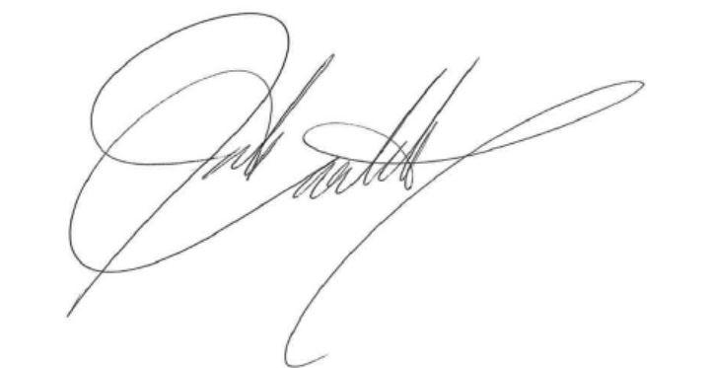Should you have any questions or wish to discuss the matter further, please contact me directly at [giovanni@ogca.ca](mailto:giovanni@ogca.ca).

Sincerely,

Giovanni Cautillo

President

Ontario General Contractors Association